BCRP National Standards
BCRP Partnership Principles & Standards
SELF ASSESSMENT TOOL
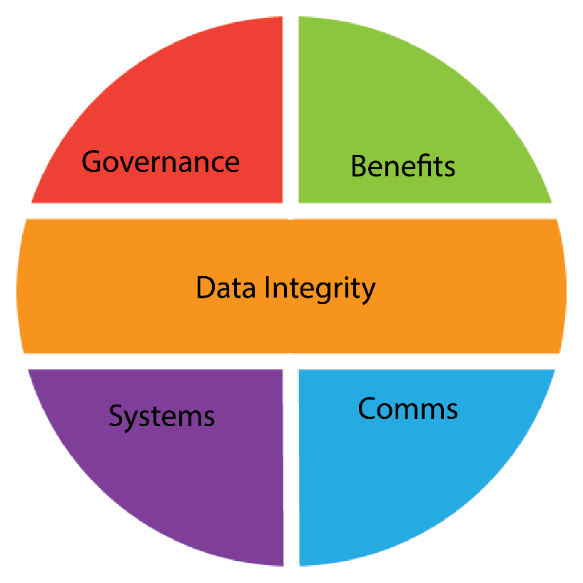
2018 Version 1

How to complete the form
This document is designed to be completed using a computer and submitted via email. After downloading please resave this file by prefixing the existing file name with your scheme name i.e. your scheme nameAccreditation.doc. When there is a request for documentary evidence these should be supplied in digital form wherever possible (Word file, PDF, or scanned document). Please label with the corresponding subsection number (e.g. 1.2). Once this is done you should save the folder as a .zip file and attach to an email together with this completed (and renamed) accreditation document to your Assessor.
Example
Standard  Each standard will be assessed as scoring between 1 – 5. | Comments | 1. Significantly  Below Standard | 2. Below Standard | 3. Standard Met | 4. Above Standard | 5. Excellent/ Outstanding
1.1 In order to attain Accreditation all sections with a green background are deemed Essential and must be achieved to receive overall accreditation. | Key your information and commentary here.  The box will automatically expand to fit your text  Decide how strong you think you think your evidence is on the right and tick the box |  |  | √
1.2 For standards with a grey background, these are considered Desirable, but this might vary depending on what the partnership* covers i.e. retail schemes will have different needs to a Pubwatch for example. | Example: Documents supplied digitally |  |  |  | √
1.3 Standards with a yellow background are Optional for all partnerships | Example: Documents supplied as hard copies by post |  | √
*Note: The term “partnership” is used through to cover a broad variety of management arrangements for BCRPs e.g. Shop Watch, Pub Watch, Retailers Against Crime etc.

Introduction
There are a very broad range of partnerships, all dedicated to reducing crime. Not every partnership will need to achieve the standard in every category. For example, if you don’t have radios or CCTV then those sections are Not Applicable. If you do use radios, then the standards set need to be met to achieve accreditation

1. Overview & Governance Structure
1.1 Partnership Name:

1.2 Partnership Address:

1.3 Partnership Manager:

1.4 What business sectors does your Partnership serve?
For example: Retail, pubs and clubs etc.

1.5 What is the legal status of your partnership? Please specify
Legal Status: There are a range of formats for partnerships, include Company Limited by Guarantee or Community Interest Company through to an ad hoc partnership, which has no legal standing.

1.6 The governance structure should be clearly set out
Supplied YES or NO
Please provide a copy of Memorandum & Articles of Association, Constitution or similar.
Note: Your constitution must set out the principles, governance system and rules of your partnership.

1.7 Does the scheme have a Board of Management or Steering Group?
Please state YES or NO
If YES please show the names and occupations of the board members
If NO - please show the partnership structure along with the names and occupations of those involved.

1.8 Annual General Meeting:
Produce minutes of the last AGM or if you are a new scheme any proposed dates for your first AGM.

Partnership Benefits, Aims and Objectives
Having clear objectives and identifying the benefits, providing value is an essential element in ensuring the success of your scheme:
- Promoting the importance and usefulness of your scheme will help your membership grow and increase participation.
Making your scheme accessible will help achieve maximum participation:
- Your members should be able to access information at a time and place that is convenient to them.
- Software systems now make information securely available via the internet and mobile phones.
- Accessibility should be combined with usability and affordability.

2. Partnership, Benefits aims and objectives
2.1 What is the Vision or Strategic Aim of your scheme?  Your Strategic Aim should be a very clear statement of what your scheme aims to do for your members and their community. |  | 1 | 2 | 3 | 4 | 5
2.2 Evidence the benefits and value your scheme brings to its members and the community it was set up to serve:  What is the “business case” for the scheme? Include details of any business plan, your current priorities i.e. annual action plan.  The perceived value can be as simple as a financial or membership benefit or it can be a wider community benefit. |  | 1 | 2 | 3 | 4 | 5
2.3 Evidence how you measure your partnerships performance:  Possible sources of evidence: Monitoring radio usage logs, No. of offenders recorded, regular meetings etc. This may include Q & A or interviews. |  | 1 | 2 | 3 | 4 | 5
2.4 Evidence that your scheme produces effective information from the data it collects to help in the management and delivery of the crime reduction initiative: |  | 1 | 2 | 3 | 4 | 5
2.5 What number of active members do you have and what measures are you taking to increase active participation? |  | 1 | 2 | 3 | 4 | 5
2.6 Evidence that you are helping your members tackle crime & disorder. |  | 1 | 2 | 3 | 4 | 5
2.7 Produce evidence that your contact list of scheme members is up to date and regularly reviewed. |  | 1 | 2 | 3 | 4 | 5
2.8 Are you sharing information with other crime reduction schemes in your local area?  Please state YES, or NO  If YES please tell us how? |  |  |  |  |  | YES
2.9 Evidence that you conduct training or presentations to your members and staff in order that they can make the best use of the Partnership systems and procedures: |  | 1 | 2 | 3 | 4 | 5
2.10 Do you have use of a civil recovery scheme?  Please state YES, or NO  If YES - produce evidence: |  | 1 | 2 | 3 | 4 | 5
2.11 Do you manage both daytime and night time economies in your area?  If YES, this becomes “Essential” evidence. |  |  |  |  |  | YES

Communications
Communicating with members is vital:
We live in a 24/7 society and in an age when businesses can become victim to cross border crime. Ideally, accreditation will allow schemes to make up to date information readily available and to be interrogated by its members, the police and other statutory bodies 24 hours a day 365 days per year.
Having an overall communication strategy will help frame how and why you engage with your members
3. Communications
3.1 Evidence how you engage with and communicate with your members and how they can engage and communicate with you:  . |  | 1 | 2 | 3 | 4 | 5
3.2 Evidence that your partnership has a distinctive logo/identity and that it is used to raise awareness of the scheme within the community: |  | 1 | 2 | 3 | 4 | 5
3.3 Evidence that your partnership works to raise its profile: |  | 1 | 2 | 3 | 4 | 5
3.4 Evidence that you hold Intelligence Briefings for your members and other groups in the area e.g. Pub Watch (if applicable). |  | 1 | 2 | 3 | 4 | 5
3.5 Evidence that you conduct a satisfaction survey of your members or evaluation at least annually to identify ways of improving your scheme and service delivery as well as training needs. |  | 1 | 2 | 3 | 4 | 5
3.6 Show how you induct new members: |  | 1 | 2 | 3 | 4 | 5
3.7 Evidence that you provide feedback to member at least annually. |  | 1 | 2 | 3 | 4 | 5

Systems & Procedures
A well-structured partnership will enable its members to understand the relationship between the various elements of the scheme.
Clear and concise documented procedures and protocols will also act as a user guide for the scheme members. It will also help ensure that you are compliant with current legislation
Informative & easy to use - Understood by everyone including those with the lowest skill level:
People are essential for your scheme to thrive and people will bring your scheme alive.
Keeping your systems simple but effective is the key to your schemes success and for increasing community engagement.
The easier it is for someone to learn how to use, operate or manage your scheme the quicker they will take an active part in it.
4. Systems & Procedures
4.1 Evidence how you demonstrate your partnership’s cost effectiveness? |  | 1 | 2 | 3 | 4 | 5
4.2 Show how you encourage the police and other key stakeholders to be involved in your scheme and describe their involvement: |  | 1 | 2 | 3 | 4 | 5
Health and safety checklist
Insurance
4.3 Do you have the appropriate insurance in place?  Please state YES, or NO  If YES - produce evidence of Professional Indemnity Insurance, Public Liability or Employee Liability.  If NO, please tell us why not. |  |  |  |  |  | YES
Protocols
4.4 Produce evidence of your Partnership codes of practice: |  | 1 | 2 | 3 | 4 | 5
4.5 Produce evidence of your Partnership Operating Guidelines:  Possible sources of evidence: Supply copy.  . |  | 1 | 2 | 3 | 4 | 5
4.6 Produce evidence of your Partnership Information Sharing Protocol, including Audit Procedures: |  | 1 | 2 | 3 | 4 | 5
4.7 Is there an Information Sharing Agreement (ISA) in place with the police?  Please state YES, or NO  If YES, please provide a copy.  When was it last reviewed? |  |  |  |  |  | YES
4.8 What do you have in place to prevent Partnership disruption caused by the loss of key staff or disaster?  P |  | 1 | 2 | 3 | 4 | 5
Exclusion Notice Scheme
4.9 Does your Partnership have an exclusion or banning notice scheme?  Please state YES, NO  If YES include the criteria for issuing an exclusion notice, who can and when an exclusion notice can be served. Evidence how your exclusion scheme empowers your members and victims of crime.  If YES, please complete 4.10 & 4.11  If NO, please say why. Go to 4.12 |  |  |  |  |  | YES
4.10 Produce evidence of your Exclusion Notice protocol/procedure:  . |  | 1 | 2 | 3 | 4 | 5
4.11 Evidence that your schemes current and up to date list of excluded persons is accessible 24/7 to the police and members. |  | 1 | 2 | 3 | 4 | 5
Radio, Push to Talk (PTT) or VOIP Scheme
4.12 Does your Partnership use a Radio or other voice communications scheme including instant notifications?  Please state YES, explain what type and answer to 4.14  If NO, please say why not and go to 4.15 |  | 1 | 2 | 3 | 4 | 5
- How many members are users? |  | 1 | 2 | 3 | 4 | 5
b) Who owns the hardware?  (The Partnership or are they leased from a 3rd party?) |  | 1 | 2 | 3 | 4 | 5
c) Evidence that the scheme is licensed. |  | 1 | 2 | 3 | 4 | 5
4.13 Produce evidence that you have a voice Scheme Protocol in place: |  | 1 | 2 | 3 | 4 | 5
4.14 Produce evidence that you undertake training or produce a user guide for the radio. |  | 1 | 2 | 3 | 4 | 5
CCTV
4.15 If you have a CCTV control room, do staff have use of or access to your Partnerships Radio Scheme?  Please state YES, or NO  If NO - produce evidence that this facility has been offered to them and state reasons why they have declined the offer and Go to 4.18 |  |  |  |  |  | YES
4.16 Do the police monitor or access your Partnerships Radio Scheme?  Please state YES, or NO  If NO - produce evidence that this facility has been offered to them and state reasons why they have declined the offer. |  |  |  |  |  | YES
4.17 Have CCTV control room staff got 24/7 access to your Partnerships up to date relevant information and images?  Please state YES, or NO  If YES - produce evidence:  If NO - state reasons why: |  |  |  |  |  | YES
Financial Sustainability
4.18 Produce evidence of your partnerships accounts.  Note: This may be as part of a larger entity i.e. a BID in which case please show the proportion of the levy spent on the BCRP |  | 1 | 2 | 3 | 4 | 5
4.19 Produce evidence of financial stability. |  | 1 | 2 | 3 | 4 | 5
4.20 Do you have a paid staff or a coordinator?  Please state YES, or NO  If YES – please state work patterns  If NO – please explain how the scheme is managed. |  |  |  |  |  | YES

Data Integrity
This is the “backbone” of the scheme.
Protecting yourself and your members is paramount. These questions will give everyone the reassurances they need.
See Appendix for Guidance notes
5. Data Integrity
5.1 Produce evidence that your scheme is registered with the ICO. |  | 1 | 2 | 3 | 4 | 5
5.2 Produce details of the schemes data controllers.  . |  | 1 | 2 | 3 | 4 | 5
5.3 Evidence that partnership data is held and stored securely. |  | 1 | 2 | 3 | 4 | 5
5.4 Produce evidence of your data sharing protocol. |  | 1 | 2 | 3 | 4 | 5
5.5 Produce evidence of information or advice given to business members to assist them to comply with the DPA in relation to data security, use and third party disclosure. |  | 1 | 2 | 3 | 4 | 5
5.6 Evidence Data integrity and membership agreements that are in place with members. |  | 1 | 2 | 3 | 4 | 5
5.7 Evidence that your members can securely access and interrogate up to date information 24/7.  (Please note this only applies to information they have access permissions to view in accordance with the Data Protection Act) |  | 1 | 2 | 3 | 4 | 5
5.8 If you employ staff show evidence that you have an effective vetting policy.

The Future
THIS IS NOT PART OF THE ACCREDITATION PROCESS

What are the key areas for development of your scheme that you hope to develop in the next 2 years?

Sharing Good Practice
THIS IS NOT PART OF THE ACCREDITATION PROCESS

The accreditation scheme aims to build mature, robust, sustainable partnerships that maximise active participation to solve community problems. It is important that we share and replicate good practice. Please tell us about any aspects of your scheme that we should be promoting to others.

