Course:  Vulnerability Awareness | Lesson Topic: |  | Day:  Session Number: |  | Date: | Time:  45 minutes
Teaching Aims: To provide those working in the licensed industry with an awareness of vulnerability and their responsibilities towards people visiting their premises |  |  | Group: Licensing Professionals |  | Trainer Name
Specific Learning Outcomes:  By the end of the lesson, the students will be able to … |  |  | Learning outcome Assessment |  | Resources:  PowerPoint
- Explore what vulnerability is within the Licensed Economy and how to identify it. |  |  | By monitoring individual & group answers to questions posed throughout the session, the trainer will draw out key points to assess progress towards this objective |  | Lesson Plan
- Identify interventions that assist in preventing and reducing harm to vulnerable people in licensed premises.  . |  |  | By monitoring individual & group answers to questions posed throughout the session, the trainer will draw out key points to assess progress towards this objective
Learner Needs/Profile:  - Differing learning styles  - No prior experience of dealing with a vulnerable person on licensed premises.  - Reflection as a student |  | Strategies for Differentiation:  - Use of a variety of media and group work planned to cater for all learning styles  - Ascertain prior-knowledge by Questions and Answers |  | Knowledge Assumed:  General knowledge of working in a licensing environment.  Conflict Management Awareness  Knowledge of the four Licensing Objectives
References:

Licensing Act 2003

Time | Topic/  Content | Teacher Activity | Student Activity | Resources
 | Vulnerability Training for whole session | Slide 1 – Vulnerability Awareness  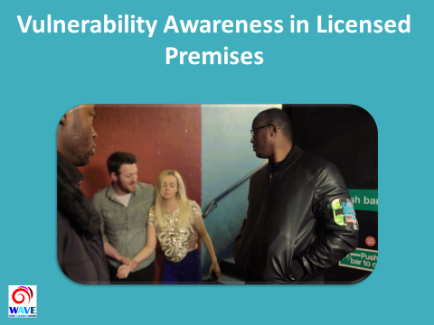  Trainer to introduce themselves  Cover House Keeping:  - Length and structure of session  - Refreshments  - location of toilets  - Emergency procedures to be followed  - Fire exists / any fire drills planned etc.  Explain – there will be 2 short videos being played, with sound  Q: Is everyone ok to start?  Explain - What does WAVE stand for - Welfare And Vulnerability Engagement  Slide 2 – AIM  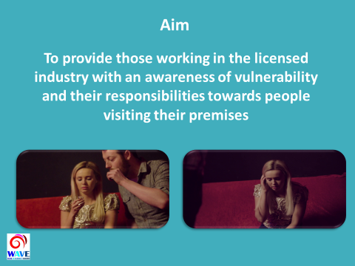  This input is focused specifically on Licensed Industry workers  However - The WAVE initiative is multi-faceted, and aims to raise awareness hollistically.  Other inputs have been developed to focus on:  - friends of vulnerable persons, mainly in university settings, and also  - the police and other stakeholders who have a direct interest in licensed premises.  Everyone can have a positive impact on people who are vulnerable  Slide 3 Our Objectives  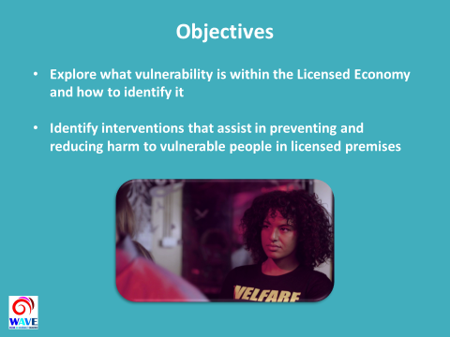  Trainer to outline the objectives  The session will:  - Explore what vulnerability is within the Licensed Economy and how to identify it.  - Identify interventions that assist in preventing and reducing harm to vulnerable people in licensed premises.  Trainer to ask - What experience do the attendees have in dealing with vulnerable people?  Points to consider to encourage discussion:  - Door supervisors already play an important role in protecting vulnerable people.  - Build on experience and share knowledge with all staff to help spot early signs of vulnerability.  - Ability to recognise vulnerable people and make interventions that will reduce the risk of harm to that person.  - The overall aim is to increase safety in the Licensed Economy.  - This doesn’t negate the need for people to look after themselves and act responsibly, however, there will be occasions when people either don’t realise the risk they face.  Slide 4 Key principle  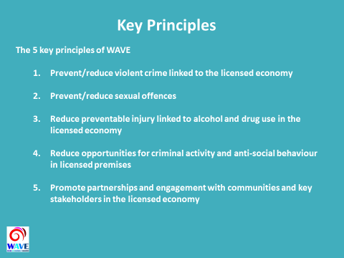  5 Principles  The 5 key principles of WAVE – ultimately a prevention and harm reduction initiative.  Important to create and strengthen Partnerships between authorities and industry stakeholders – helps to ensure initiative is a success.  WAVE initiative helps to identify people before they become potentially vulnerable, and:  - victims of crime  - victims of anti-social behaviour  - come to harm in any other way  - Involved in crime/antisocial behaviour/harm  WAVE initiative ensures vulnerable people are properly supported with positive interventions.  Slide 5 Vulnerability  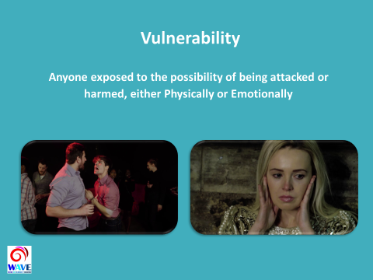  There are a number of ways of defining vulnerability - for the purpose of this session we will use the following broad definition:  ‘Anyone exposed to the possibility of being attacked or harmed, either Physically or Emotionally’  Definition from Oxford English Dictionary:  (Factors that contribute to vulnerability are explored on slide 7)  Some people may be more familiar with the term; ‘At Risk’, however in this session we will use the term vulnerability.  Slide 6 - What can make a person Vulnerable?  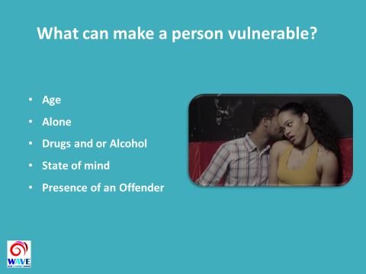  Trainer to ask attendees:  - Name some factors that may cause a person to be potentially vulnerable:  Age:  - Younger people tend to be more vulnerable to risk of harm. But age not overriding factor.  Alone:  - Separated from friends, appears lost, isolated, easily targeted.  Drugs & Alcohol:  - Reduced inhibitions - decreased ability to make decisions  - Changes perceptions of their own abilities and limitations  - Signs - overly gregarious/passive, aggressive, lack of spatial awareness, appears unwell  State of mind:  - Emotional or mental state at the time. This can be influenced by a range of factors – friends will usually notice a difference in behaviours first.  Presence of an Offender:  - Risk of potential harm increases substantially when above factors combined with the presence of a criminal offender.  Slide 7 – How to recognise vulnerability  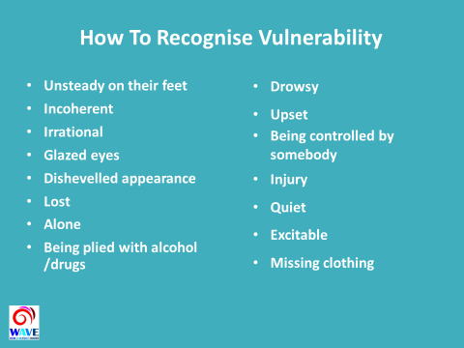  Trainer to ask attendees:  - How would they recognise that somebody was vulnerable?  Discuss with group  - A number of factors that may make someone vulnerable - list is not exhaustive.  Early identification of these signs will assist in deciding how to respond - each situation is likely to be different.  An offer to help may be refused - how you might respond to this?  Consider:  - Do you give up?  - Can you deal with things another way - are there other options?  - You may get an aggressive response.  - Has a crime taken place?  - Trust your instinct - if you have concerns then make an intervention.  Slide 8 - Video #1  Trainer to play video  Inform attendees that the video has flashing lights and upsetting imagery.  Trainer to advise - Look out for vulnerabilities throughout the video  Slide 9 - What Happened?  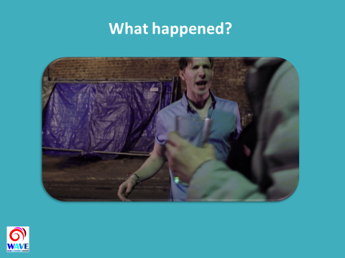  Note the scenarios depicted are not gender or crime specific  Trainer to ask the attendees:  “Consider the video from a personal perspective - how would you feel if this happened to a family member or friend?”  Trainer to lead discussion:  - What’s just happened?  - How do we feel about the video from a professional perspective? Discuss  - Welfare & Safety Officer?  - Staff interventions?  - Refusals?  - Is this an accurate reflection of events that may occur?  - Preventable?  Slide 10 – Where can we intervene to reduce vulnerability?  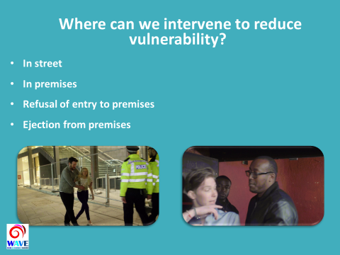  Trainer to explain where interventions can take place including:  - In street  - In premises  - Refusal of entry  - Ejection of premises  Slide 11 - Interventions?  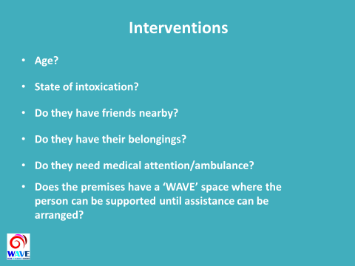  Trainer to discuss appropriate interventions:  - It is important not to leave the vulnerable person on their own.  Age?  - Is the individual vulnerable due to their age, young or old?  State of Intoxication?  - Is the individual/group so intoxicated that it is not reasonable to expect them to be able take care of themselves?  - What responsibility do you have to those refused entry?  - Are they accompanied by others who may also be seeking entry - are they capable of taking responsibility of the individuals concerned?  Do they have friends nearby?  - Where possible, attempts should be made to contact friends who may be able to assist. CCTV, ID scanners etc may well assist in identifying friends.  - Is there an opportunity to make contact with family?  Do they have their belongings?  - If persons are ejected without their belongings they may have no means to contact anyone, no money and/or appropriate clothing, which may render the person vulnerable.  - Consider how you could assist the person in getting home safely?  Do you have access to a dedicated taxi service?  Do they need medical attention / ambulance?  - Treat this as a priority and arrange immediately. Seek assistance from a colleague where possible, and obtain full details from emergency services, such as the call reference number.  - Ensure staff are aware of the location of the medical kit and ensure it is in date and the staff are trained to use it.  Does the premises have an internal safe space? (WAVE Space)  - A safe space could be a room or area where a vulnerable person can be taken and feel safe whilst arranging assistance.  - Facilities should be made available so that the vulnerable person can make contact with friends or family, and receive medical assistance, or speak to an appropriate member of staff such as a welfare officer.  - If your premises does not have a safe (WAVE) space, are there any local safe havens?  Does the premises have a Welfare Officer? (WAVE Officer)  - It is important that the welfare officer is clearly identifiable to both customers and staff, and has appropriate training, which should include vulnerability awareness and interventions training, and additionally may include conflict resolution, first aid and crime response training. They may also be accredited by the Security Industry Authority (SIA) as a Door Supervisor (or Close Protection Officer).  Is there a Street Pastor available to assist?  - A street pastor is a volunteer who can provide support and care to vulnerable persons  Slide 12 – Ask for Angela  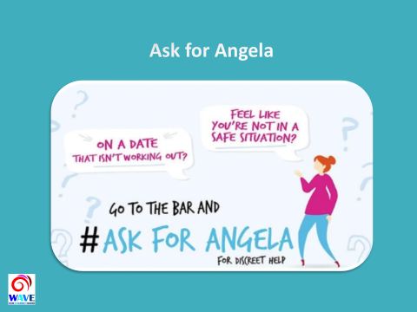  Ask For Angela provides a useful additional tool for dealing with vulnerability.  - Ask for Angela’ initiative aims to reduce sexual violence and vulnerability by providing customers with a non-descript phrase they can use to gain assistance from staff members in order to be separated from the company of someone with whom they feel unsafe due to that person’s actions, words or behaviour.  - By “asking for Angela”, an individual should be treated as a vulnerable person and the interventions discussed in this training should be applied.  Slide 13 – Pesence of an offender  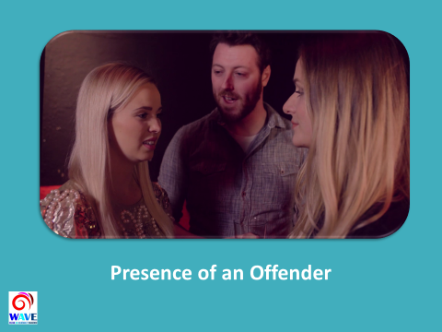  Trainer to ask - Who can commit a criminal offence?  - Anyone from any background.  - Offenders can be predatory or opportunistic in nature.  - There is no one specific demographic relating to offenders.  - Offenders may be looking to target vulnerable people to commit crime.  - An offender may be looking to take advantage of a situation for their own benefit.  Trainer to ask – What behaviours may lead you to consider that an individual may go on to commit a criminal offence, and what can be done to mitigate a potential risk?  Slide 14 - Video #2  Trainer to play video  Inform attendees that the video has flashing lights and upsetting imagery.  Trainer to advise - Consider the interventions and discuss any further opportunities for intervention, and how this can be applied to real life scenarios?  Slide 15 - Recap  Trainer to recap the session objectives. The training was designed to:  - Explore what vulnerability is within the Licensed Economy and how to identify it.  - Identify interventions that assist in preventing and reducing harm to vulnerable people in licensed premises.  - We’ve looked at the definition and what can make someone vulnerable.  - We’ve looked at visual signs that could indicate someone is vulnerable  - We’ve looked at people who may seek to exploit that vulnerability.  Trainer to ask the group - What is the benefit of adopting WAVE in your premises?  - Safer environments, reduced crime and harm, increased customer satisfaction, improved working partnerships, enhanced staff training, lower instances of ASB.  Slide 16 - Questions  Trainer to answer any questions.  Thank everyone for attending and contributing  Slide 17 Support Services  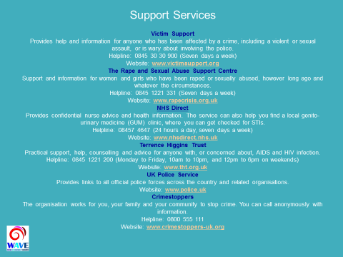  Trainer to refer to support services  Slide 18 - End of presentation.  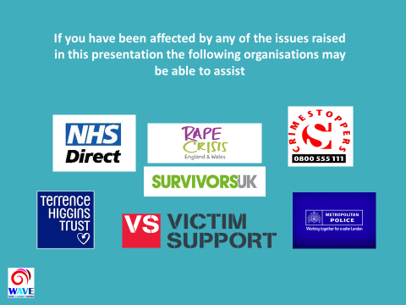  End of presentation. | Listen/  Partake  Listen/  Partake  Listen/  Partake  Listen/  Partake  Listen/  Partake  Listen/  Partake  Listen/  Partake  Watch/  Listen  Listen/  Partake  Listen/  Partake  Listen/  Partake  Listen/Partake  Listen/Partake  Watch/  Listen  Listen/Partake  Listen/Partake  Visual  Visual | PowerPoint  PowerPoint  PowerPoint  PowerPoint  PowerPoint  PowerPoint  PowerPoint  PowerPoint/  Video  PowerPoint  PowerPoint  PowerPoint  PowerPoint  PowerPoint  PowerPoint/  Video  PowerPoint  PowerPoint  PowerPoint  PowerPoint

Learner Needs/Profile – Learners’ ability, progression, physical disability, learning difficulty, learning styles, confidence, personal circumstances etc.
Strategies for Differentiation - how the trainer will adapt the lesson to meet learner needs/profile

